CHAPTER THREE

Methodology
This chapter documents the complete methodology of the Smart Diabetes Monitoring and Prediction System. Every design decision described here corresponds directly to an implemented step in the pipeline notebook, and all parameters, thresholds, and configurations reported are the exact values used in the executed code.

3.1 System Overview
The system is designed as a supervised binary classification pipeline that takes population-level behavioral health survey data as input and produces a calibrated individual diabetes risk probability as output, with the final binary prediction governed by a clinically optimized decision threshold rather than the statistical default [11], [35]. The pipeline is organized into eighteen sequential steps spanning data loading, exploratory analysis, preprocessing, feature engineering, multi-phase model evaluation, hyperparameter tuning, threshold optimization, and deployment packaging. Each step produces either a serialized artifact, a performance metric, or a visualization that feeds into subsequent steps, ensuring full reproducibility of all reported results [25], [35].
The system does not require any laboratory measurements as input. All features are derived from self-reported behavioral and demographic variables available through population health surveys, making the system deployable in any setting where a structured questionnaire can be administered [5], [12].

3.2 System Workflow and Design
The system is built around a structured and reproducible workflow that transforms raw survey data into a deployment-ready prediction tool through a sequence of well-defined stages. Each stage is designed with a specific purpose, and the output of every stage feeds directly into the next, ensuring that no preprocessing decision, feature transformation, or model selection step is made in isolation. The overall design reflects two guiding principles: clinical utility as the primary constraint on every algorithmic choice, and full reproducibility as a non-negotiable engineering requirement. The following subsections describe the pipeline architecture and the tools used to implement it.

3.2.1 Pipeline Architecture
The pipeline is structured into four progressive experimental phases, each building on the outputs of the preceding one. Phase 1 trains and evaluates all seven algorithms on the original 21 BRFSS features. Phase 2 trains and evaluates all seven algorithms on the 45-feature engineered space. Phase 3 trains and evaluates all seven algorithms on a reduced top-15 feature subset selected through combined importance ranking. Phase 4 performs hyperparameter tuning on the globally best-performing model and phase combination identified through a composite scoring function [15], [17].
At the end of Phase 4, a threshold optimization procedure identifies the highest decision threshold satisfying the clinical deployment constraint of Recall greater than or equal to 0.90. The tuned model, preprocessing components, and deployment threshold are then packaged into a unified pipeline bundle for Streamlit integration [5], [11].
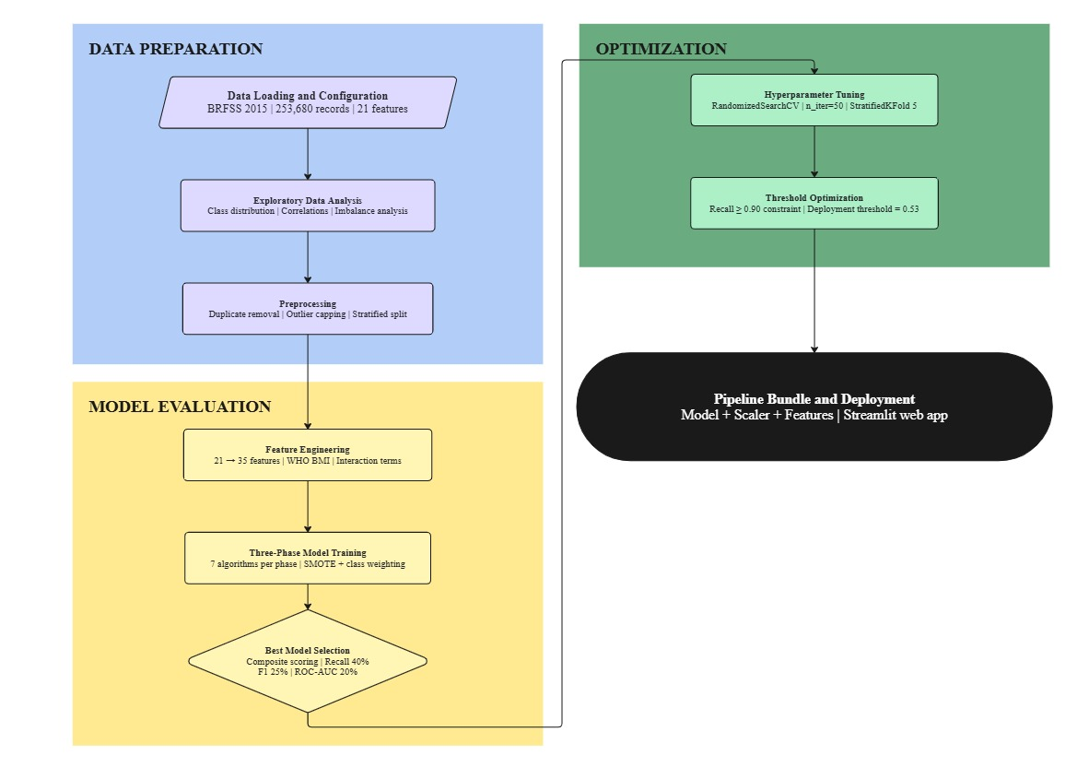
Figure 3.1 illustrates the complete system architecture and the logical flow between all eighteen pipeline steps.

Figure 3.1
System architecture and pipeline workflow of the Smart Diabetes Monitoring and Prediction System.

3.2.2 Development Environment and Tools
The pipeline is implemented in Python. Core machine learning components are drawn from Scikit-learn [25], with LightGBM [15] and XGBoost [16] providing the primary gradient boosting implementations. Imbalanced-learn provides the SMOTE oversampling implementation [22]. Data manipulation is handled through NumPy and pandas, and all visualizations are produced using Matplotlib and Seaborn. The random seed is fixed globally at a constant integer value across all stochastic operations to ensure reproducibility.

3.3 Dataset Description

3.3.1 BRFSS 2015 Dataset Overview
The dataset used in this project is the preprocessed version of the 2015 Behavioral Risk Factor Surveillance System survey, originally collected by the Centers for Disease Control and Prevention [12] and prepared for machine learning use by Teboul [13]. The BRFSS is an annual United States telephone health survey system that collects data on health behaviors, chronic conditions, and use of preventive services from adults across all fifty states [12].
The dataset comprises 253,680 records and 22 columns, of which 21 are input features and one is the binary target variable Diabetes_binary, where a value of 1 indicates diabetes or prediabetes and a value of 0 indicates no diabetes [13]. All features are either binary indicators or ordinal survey response codes, with no continuous floating-point measurements and no missing values reported in the source [13].

3.3.2 Feature Descriptions and Data Types
The 21 original features fall into two groups. Fourteen are binary indicator variables capturing the presence or absence of specific health conditions and behaviors. Seven are ordinal categorical variables capturing graded health and demographic attributes. Table 3.1 provides the complete feature list with data type and value range for each variable [12], [13].

Table 3.1
Description, data type, and value range of all 21 original BRFSS 2015 features.

Feature | Type | Values
HighBP | Binary | 0 = No, 1 = Yes
HighChol | Binary | 0 = No, 1 = Yes
CholCheck | Binary | 0 = No, 1 = Yes
Smoker | Binary | 0 = No, 1 = Yes
Stroke | Binary | 0 = No, 1 = Yes
HeartDiseaseorAttack | Binary | 0 = No, 1 = Yes
PhysActivity | Binary | 0 = No, 1 = Yes
Fruits | Binary | 0 = No, 1 = Yes
Veggies | Binary | 0 = No, 1 = Yes
HvyAlcoholConsump | Binary | 0 = No, 1 = Yes
AnyHealthcare | Binary | 0 = No, 1 = Yes
NoDocbcCost | Binary | 0 = No, 1 = Yes
DiffWalk | Binary | 0 = No, 1 = Yes
Sex | Binary | 0 = Female, 1 = Male
BMI | Ordinal/Continuous | Integer values
GenHlth | Ordinal | 1 = Excellent to 5 = Poor
MentHlth | Ordinal | 0 to 30 days
PhysHlth | Ordinal | 0 to 30 days
Age | Ordinal | 1 = 18-24 to 13 = 80 or older
Education | Ordinal | 1 = Never attended to 6 = College graduate
Income | Ordinal | 1 = Less than $10,000 to 8 = $75,000 or more

Figure 3.2 shows the point-biserial correlation between each of these features and the binary target variable, providing the initial empirical basis for feature relevance assessment.

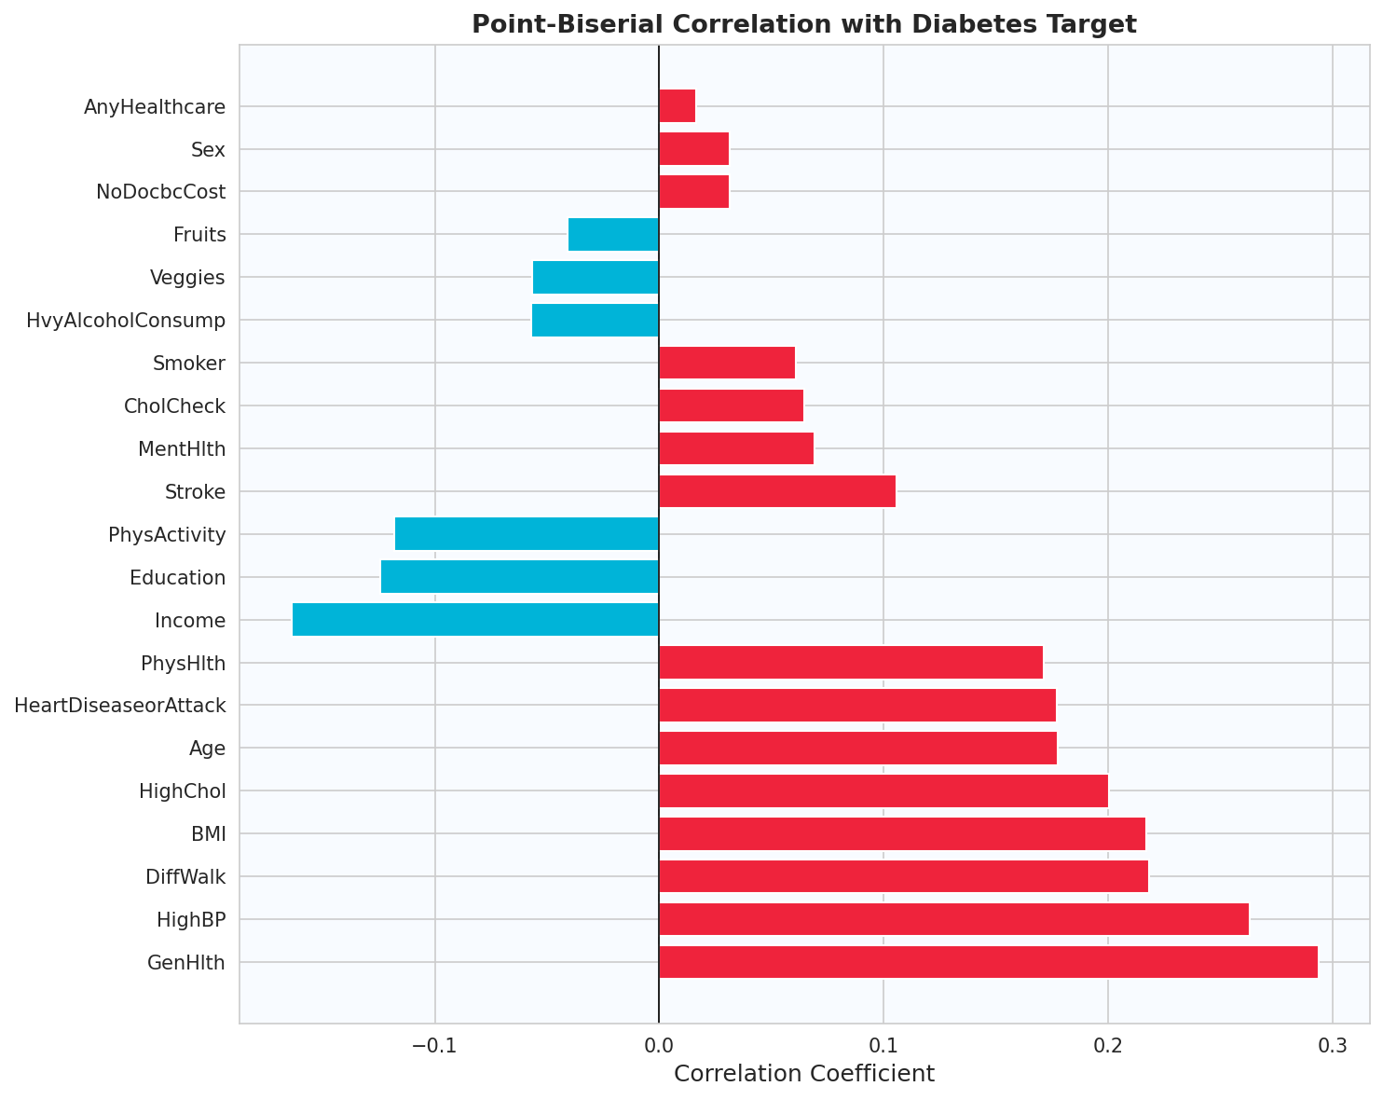

Figure 3.2
Point-biserial correlation coefficients between each original BRFSS 2015 feature and the Diabetes_binary target variable.

3.3.3 Class Distribution and Imbalance Analysis
Of the 253,680 records, approximately 218,334 belong to the non-diabetic class and approximately 35,346 belong to the diabetic or prediabetic class, yielding a majority-to-minority imbalance ratio of approximately 6.2 to 1 [12]. The non-diabetic class represents approximately 86 percent of all records and the diabetic class approximately 14 percent. This imbalance ratio is clinically realistic, reflecting actual population-level diabetes prevalence, and it is sufficiently severe to cause systematic minority-class suppression in all standard classifiers trained without explicit imbalance mitigation [9], [10]. Figure 3.2 illustrates the class distribution.

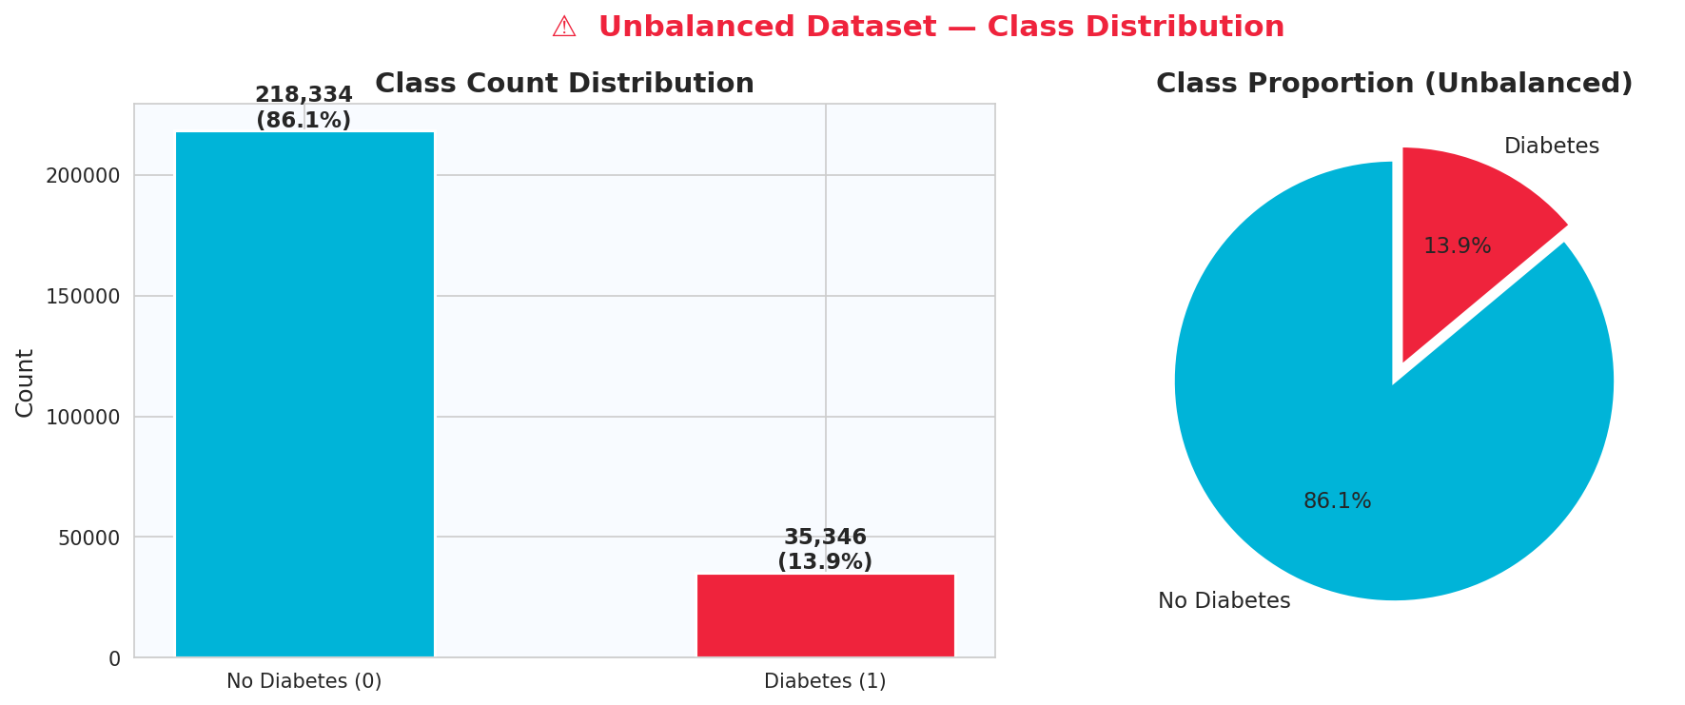

Figure 3.3
Class distribution of the Diabetes_binary target variable in the BRFSS 2015 dataset showing the 86/14 majority-to-minority imbalance ratio.

3.4 Data Preprocessing

3.4.1 Exploratory Data Analysis
Prior to any transformation, a systematic exploratory data analysis is conducted across all 22 columns of the raw dataset. Features are partitioned into binary columns, defined as those with exactly two unique values, and continuous columns, defined as those with more than two unique values. Target class counts and percentages are computed and visualized. Point-biserial correlations between each feature and the binary target variable are computed using pointbiserialr from scipy.stats to quantify the linear association between each input and the outcome [39]. Continuous feature distributions are examined by class through overlaid histograms and side-by-side boxplots to identify the features with the greatest distributional separation between diabetic and non-diabetic records.

3.4.2 Duplicate and Missing Value Treatment
The raw dataset is checked for duplicate records. All exact duplicate rows are removed using pandas drop_duplicates prior to any splitting or scaling operation. Missing value analysis confirms that no missing values are present in the BRFSS 2015 preprocessed dataset, requiring no imputation [13].

3.4.3 Outlier Detection and Capping
Outlier capping is applied exclusively to the continuous features: BMI, GenHlth, MentHlth, PhysHlth, Age, Education, and Income. For each continuous feature, the 1st and 99th percentiles are computed on the full dataset. Lower and upper clip boundaries are defined using Equation 3.1 and Equation 3.2 respectively.

Lower bound = Q1 − 1.5 × IQR (Equation 3.1)

Upper bound = Q3 + 1.5 × IQR (Equation 3.2)

Where Q1 is the 1st percentile, Q3 is the 99th percentile, and IQR = Q3 − Q1. All values falling outside these boundaries are clipped to the boundary value. The number of capped values per feature and the boundary values are logged and serialized for deployment reproducibility. Figure 3.4 shows the distribution of continuous features prior to capping.
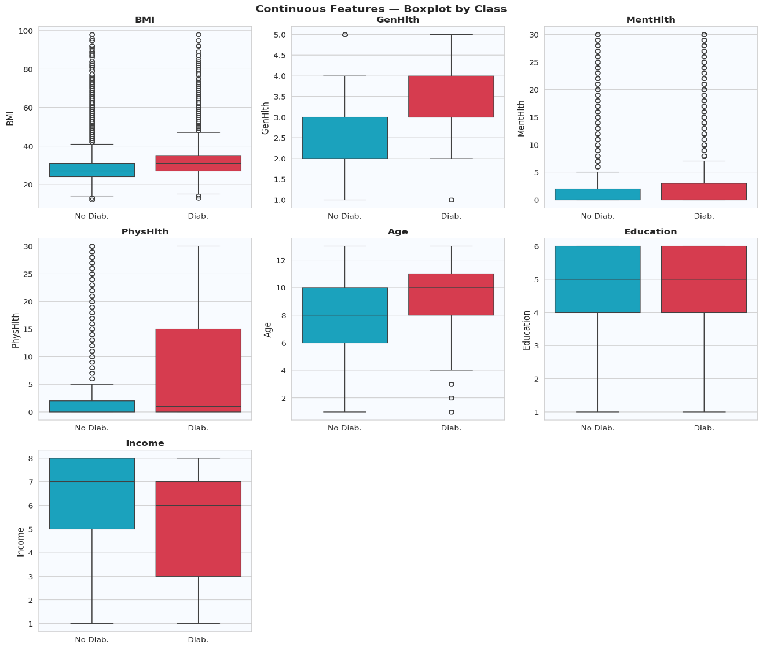

Figure 3.4
Boxplots of continuous features illustrating value ranges and outlier distribution prior to IQR-based capping, BRFSS 2015 dataset.

3.4.4 Feature Scaling with RobustScaler
Following outlier capping and train-test splitting, all features are scaled using RobustScaler from Scikit-learn [25]. RobustScaler centers each feature by subtracting its median and scales by its interquartile range, making the transformation resistant to the influence of remaining extreme values that capping alone does not eliminate [36]. The scaler is fitted exclusively on the training set and applied to both training and test sets to prevent data leakage. A separate scaler instance is fitted on the engineered feature training set for use in Phases 2 and 3.

3.4.5 Imbalance Handling Strategy
The imbalance handling strategy operates at three distinct levels, as recommended by the survey literature [23]. At the data level, SMOTE is demonstrated on a representative 10,000-record subset to illustrate the effect of synthetic oversampling on class distribution. The actual model training in this pipeline relies on algorithm-level weighting rather than data-level resampling, as the scale_pos_weight and class_weight mechanisms provide sufficient and more controlled minority-class amplification without modifying the training data distribution [22], [9]. At the algorithm level, all models are configured with explicit cost-sensitive weighting mechanisms described in detail in Section 3.6.3. At the evaluation level, overall accuracy is replaced entirely by clinically appropriate metrics including Recall, F1-Score, Balanced Accuracy, PR-AUC, and MCC as the primary reporting and selection criteria [44], [31]. Figure 3.5 illustrates the effect of SMOTE on the class distribution of a representative training subset.

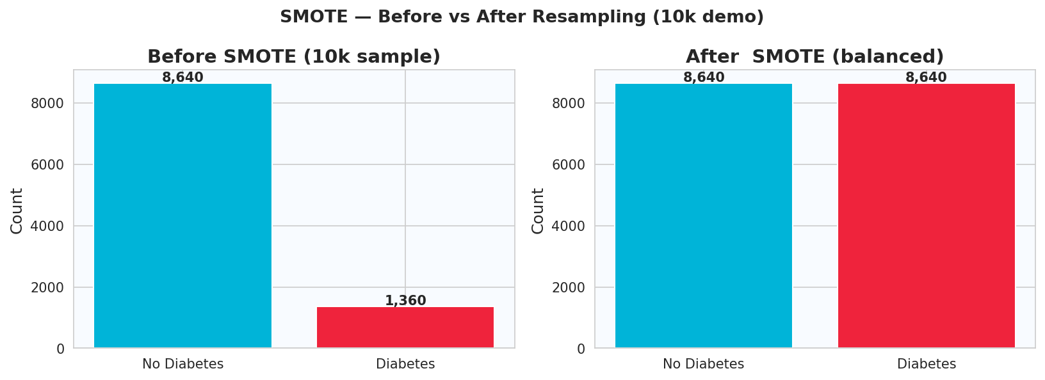

Figure 3.5
Effect of SMOTE oversampling on class distribution before and after minority class augmentation on a 10,000-record training subset.

3.5 Feature Engineering and Selection

3.5.1 Domain-Informed Feature Engineering
A custom feature engineering function is applied to the full dataset after outlier capping and before train-test splitting, expanding the original 21-feature representation to 45 features by adding 24 engineered attributes. Each engineered feature is derived from clinical domain knowledge about diabetes risk factors and their interactions [3], [37].

3.5.2 WHO BMI Category Encoding
Five binary indicator variables are created to encode the World Health Organization's standard BMI classification thresholds [37]: BMI_Underweight (BMI less than 18.5), BMI_Normal (18.5 to less than 25.0), BMI_Overweight (25.0 to less than 30.0), BMI_Obese (BMI 30.0 or above), and BMI_SevereObese (BMI 35.0 or above). These encodings transform the single continuous BMI variable into a set of clinically interpretable threshold-defined risk indicators aligned with the guidelines used in clinical practice [3], [37].

3.5.3 Composite Risk Score Construction
Three composite scores are constructed by combining multiple binary risk indicators. CompositeRiskScore is the sum of HighBP, HighChol, Smoker, Stroke, HeartDiseaseorAttack, and DiffWalk, producing an integer-valued aggregate burden score ranging from 0 to 6. CardioRisk combines the product of HighBP and HighChol with HeartDiseaseorAttack and Stroke, weighting the co-occurrence of hypertension and hypercholesterolemia more heavily as a synergistic cardiovascular risk indicator. LifestyleScore is computed as the sum of PhysActivity, Fruits, and Veggies minus Smoker and HvyAlcoholConsump, producing a net lifestyle quality index in which protective behaviors increase the score and harmful behaviors decrease it [3].

3.5.4 Interaction Terms and Non-linear Features
Three pairwise interaction terms are constructed: BMI_x_PhysActivity, Age_x_BMI, and GenHlth_x_BMI. These terms capture the joint effect of two features that clinical evidence suggests interact non-additively in their relationship to diabetes risk. Three polynomial expansion terms are also created: GenHlth_Sq, BMI_Sq, and Age_Sq, providing non-linear representations of the three strongest continuous predictors identified in the EDA phase [17], [19].

3.5.5 Additional Engineered Features
Four additional features are constructed. HealthAccess is computed as AnyHealthcare minus NoDocbcCost, encoding net healthcare accessibility as a single signed variable. HealthBurden normalizes the sum of MentHlth and PhysHlth by dividing by 60, producing a health burden index in the range 0 to 1. SocioEconomic is the product of Income and Education, serving as a composite socioeconomic proxy. HighRiskFlag is a binary indicator equaling 1 when HighBP, HighChol, and BMI_Obese are all simultaneously equal to 1, flagging the highest-risk compound metabolic profile. AlcSmoke is the sum of HvyAlcoholConsump and Smoker. UncheckedRisk flags individuals with CholCheck equal to 0 and CompositeRiskScore greater than 2. Three age bracket indicators encode the BRFSS age category into AgeGroup_Senior, AgeGroup_Middle, and AgeGroup_Young. MentalPhysRatio is computed as MentHlth divided by (PhysHlth + 1), with the denominator incremented by 1 to prevent division by zero [3], [37].
Table 3.2 provides the complete list of all 24 engineered features with their construction formula, output type, and clinical rationale. Figure 3.6 shows the distribution of selected engineered features by diabetes class.

Table 3.2
Complete list of 24 engineered features, construction formula, output type, and clinical rationale.
Feature | Formula | Type | Clinical Rationale
CompositeRiskScore | HighBP + HighChol + Smoker + Stroke + HeartDiseaseorAttack + DiffWalk | Integer 0-6 | Aggregate metabolic and cardiovascular burden
BMI_Underweight | BMI < 18.5 | Binary | WHO underweight threshold [37]
BMI_Normal | 18.5 <= BMI < 25.0 | Binary | WHO normal weight threshold [37]
BMI_Overweight | 25.0 <= BMI < 30.0 | Binary | WHO overweight threshold [37]
BMI_Obese | BMI >= 30.0 | Binary | WHO obesity threshold [37]
BMI_SevereObese | BMI >= 35.0 | Binary | WHO severe obesity threshold [37]
BMI_x_PhysActivity | BMI * PhysActivity | Continuous | Joint adiposity and inactivity interaction
Age_x_BMI | Age * BMI | Continuous | Joint aging and adiposity risk
Feature | Formula | Type | Clinical Rationale
GenHlth_x_BMI | GenHlth * BMI | Continuous | Perceived health and weight interaction
CardioRisk | (HighBP * HighChol) + HeartDiseaseorAttack + Stroke | Integer 0-3 | Synergistic cardiovascular risk
LifestyleScore | PhysActivity + Fruits + Veggies − Smoker − HvyAlcoholConsump | Integer -2 to 3 | Net lifestyle quality index
HealthAccess | AnyHealthcare − NoDocbcCost | Integer -1 to 1 | Net healthcare accessibility
HealthBurden | (MentHlth + PhysHlth) / 60 | Continuous 0-1 | Normalized combined health burden
GenHlth_Sq | GenHlth² | Continuous | Non-linear general health signal
BMI_Sq | BMI² | Continuous | Non-linear adiposity signal
Age_Sq | Age² | Continuous | Non-linear aging risk signal
SocioEconomic | Income * Education | Continuous | Composite socioeconomic proxy
AgeGroup_Senior | Age >= 9 | Binary | Senior age bracket flag
AgeGroup_Middle | 5 <= Age < 9 | Binary | Middle age bracket flag
AgeGroup_Young | Age < 5 | Binary | Young age bracket flag
HighRiskFlag | HighBP=1 AND HighChol=1 AND BMI_Obese=1 | Binary | Compound highest-risk metabolic profile
AlcSmoke | HvyAlcoholConsump + Smoker | Integer 0-2 | Combined substance burden
UncheckedRisk | CholCheck=0 AND CompositeRiskScore > 2 | Binary | Unmonitored elevated risk proxy
MentalPhysRatio | MentHlth / (PhysHlth + 1) | Continuous | Relative mental to physical health burden

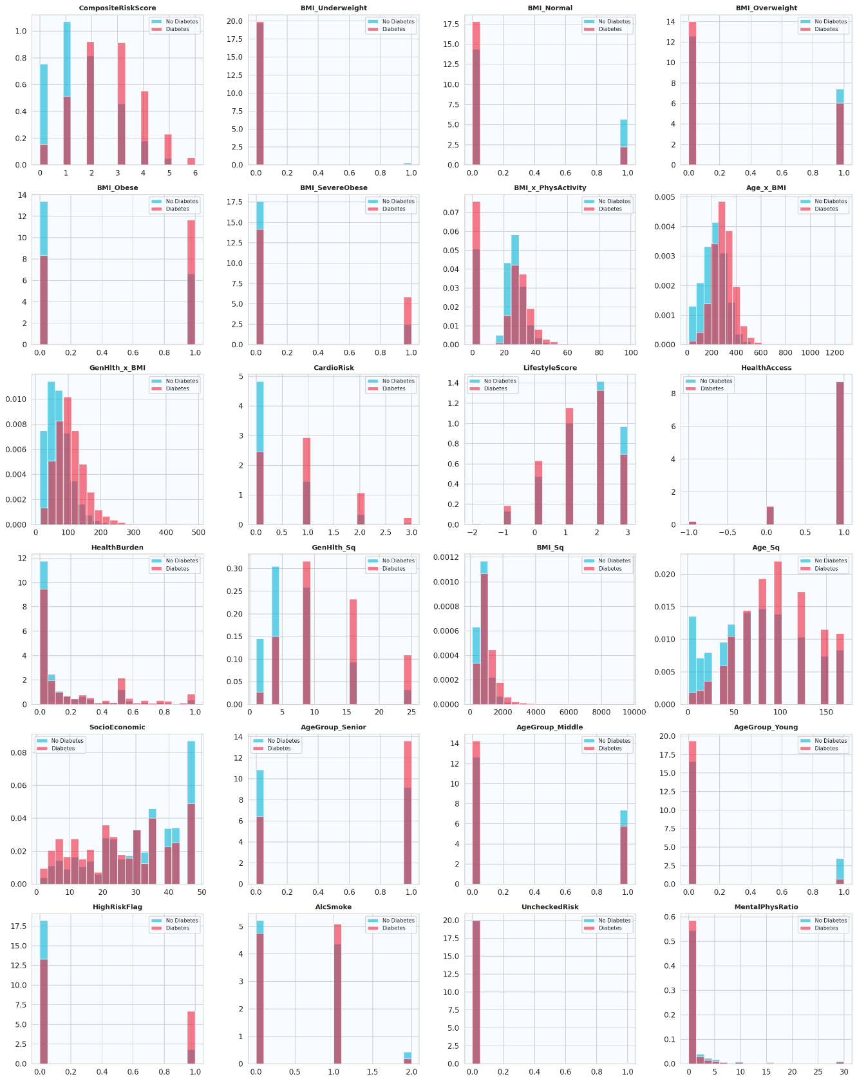

Figure 3.6
Distribution of engineered features by diabetes class in the BRFSS 2015 dataset.

3.5.6 Feature Importance Analysis and Top-15 Selection
Feature importance is assessed using two independent methods whose results are combined into a consensus ranking. The first method uses Random Forest Mean Decrease in Impurity (MDI), which measures the average reduction in Gini impurity contributed by each feature across all trees and all splits as given in Equation 3.3 [17].
$\text{Importance}\left(j\right)=\frac{1}{T}\sum_{t=1}^{T}{\sum_{v∈\text{nodes splitting on }j}{p\left(v\right)}}×Δ\text{Gini}\left(v\right)$(Equation 3.3)
Where p(v) is the proportion of training samples reaching node v and ΔGini(v) is the Gini impurity reduction at that node.
The second method uses Mutual Information scores computed by mutual_info_classif from Scikit-learn, which measures the statistical dependence between each feature and the binary target as given in Equation 3.4 [38].
$MI\left(X;Y\right)=\sum_{x}{\sum_{y}{P\left(X=x,Y=y\right)}}×log\left(\frac{P\left(X=x,Y=y\right)}{P\left(X=x\right) P\left(Y=y\right)}\right)$ (Equation 3.4)
Unlike point-biserial correlation, mutual information captures non-linear statistical dependencies and therefore provides a complementary and more complete picture of feature relevance [38]. Each feature receives a rank under both methods, and the two ranks are summed to produce a combined rank score. The 15 features with the lowest combined rank are selected for Phase 3 training. Figure 3.7 shows the consensus ranking.
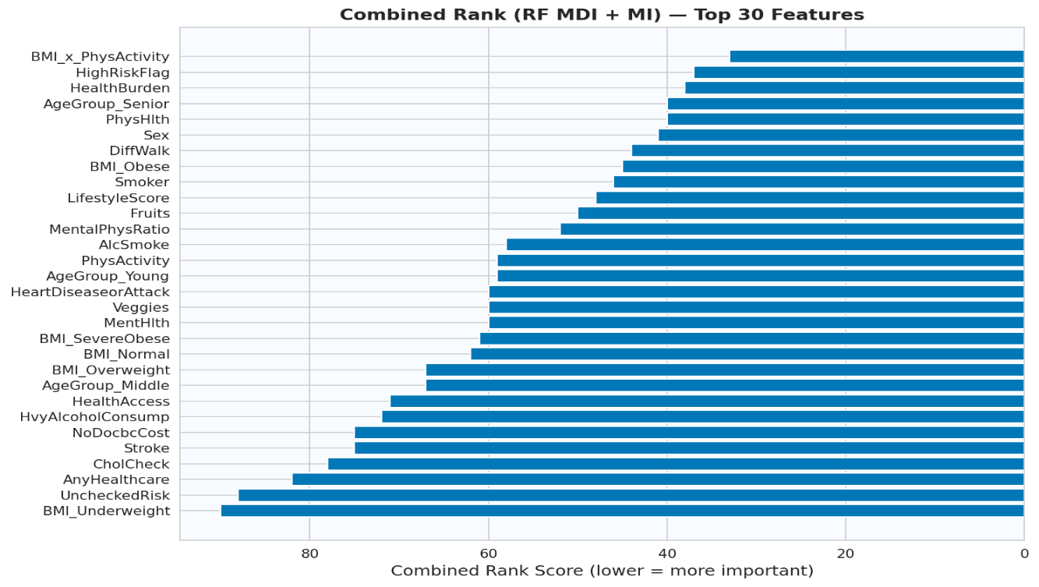

Figure 3.7
Combined Random Forest MDI and Mutual Information consensus ranking of the top 15 selected features.

3.6 Model Architecture

Figure 3.7
Combined Random Forest MDI and Mutual Information consensus ranking of the top 15 selected features.

3.6.1 Baseline Models
Seven classification algorithms are evaluated across all three experimental phases. Table 3.3 provides the complete configuration of each algorithm including its imbalance handling mechanism.

Table 3.3
Configuration of the seven classification algorithms used across all experimental phases including imbalance handling mechanism.
Algorithm | Library | Key Parameters | Imbalance Handling
Logistic Regression | Scikit-learn | max_iter=1000 | class_weight="balanced"
Random Forest | Scikit-learn | n_estimators=200 | class_weight="balanced"
Extra Trees | Scikit-learn | n_estimators=200 | class_weight="balanced"
Gradient Boosting | Scikit-learn | n_estimators=200 | None
AdaBoost | Scikit-learn | n_estimators=100 | None
XGBoost | XGBoost | n_estimators=200, eval_metric="logloss" | scale_pos_weight=6
LightGBM | LightGBM | n_estimators=200, min_child_samples=5, min_split_gain=0.0 | class_weight="balanced"  scale_pos_weight=6

CatBoost is additionally included as a conditional eighth algorithm when available in the execution environment, employing ordered boosting and native support for categorical features as a further gradient boosting comparator [40].
Logistic Regression serves as the linear baseline. It estimates the probability of the positive class through the sigmoid transformation of a linear combination of input features, as given in Equation 3.5 [21].
$P\left(y=1 ∣ x\right)=\frac{1}{1+exp\left(-\left(β_{0}+β_{1}x_{1}+β_{2}x_{2}+⋯+β_{n}x_{n}\right)\right)}$ (Equation 3.5)
Its linear assumption in log-odds space makes it the weakest candidate for modeling the complex non-linear interactions among diabetes risk factors, but it establishes the minimum performance floor against which all ensemble methods are compared [21].
All tree-based algorithms use Gini impurity as the node splitting criterion. For binary classification, the Gini impurity at a node is given by Equation 3.6 [17], [19].

$\text{Gini}=2×p_{1}×\left(1-p_{1}\right)$(Equation 3.6)

Where p₁ is the proportion of positive class samples at the node. A split is accepted when the weighted Gini impurity of the two resulting child nodes is lower than that of the parent node.

3.6.2 LightGBM Architecture and Configuration
LightGBM is the primary model of interest, based on its documented superiority on structured tabular healthcare data and its specific architectural advantages for imbalanced classification [15], [28]. Gradient boosting constructs a prediction function as an additive ensemble of M weak learners, as given in Equation 3.7 [19].

$F_{M}\left(x\right)=F_{0}\left(x\right)+\sum_{m=1}^{M}{η} h_{m}\left(x\right)$(Equation 3.7)

Where F₀(x) is the initial prediction, η is the learning rate, and hₘ(x) is the m-th tree fitted to the negative gradient of the binary cross-entropy loss function, as given in Equation 3.8 [19], [15].

$L\left(y,F\right)=-\left[ylog\left(σ\left(F\right)\right)+\left(1-y\right)log\left(1-σ\left(F\right)\right)\right]$(Equation 3.8)

Where $σ\left(F\right)=\frac{1}{1+\exp\left(-F\right)}$ is the sigmoid function.
XGBoost extends this framework with a second-order Taylor approximation of the loss and explicit L1 and L2 regularization terms, providing tighter control over overfitting [16]. LightGBM further extends gradient boosting through its leaf-wise tree growth strategy, in which the leaf with the highest loss reduction is always selected for splitting rather than growing all leaves at a fixed depth level. Its Gradient-based One-Side Sampling reduces training data by retaining only large-gradient instances and a random sample of small-gradient instances, substantially reducing training time without significant loss of accuracy. Exclusive Feature Bundling reduces dimensionality by merging mutually exclusive sparse features, providing an advantage on the mixed binary and ordinal BRFSS feature set [15].

3.6.3 Imbalance Handling per Model
For algorithms supporting class_weight, the balanced weight for class k is computed as given in Equation 3.9 [9].

${ w}_{k}=\frac{n_{\text{samples}}}{n_{\text{classes}}×n_{{\text{samples}}_{k}}}$(Equation 3.9)

Applying this formula to the BRFSS 2015 dataset:

$$w_{0}=\frac{253,680}{2×218,334}=0.581$$
$$w_{1}=\frac{253,680}{2×35,346}=3.587$$

The minority class therefore receives approximately 6.18 times the weight of the majority class during training, directly counteracting the imbalance ratio. For XGBoost and LightGBM, the equivalent mechanism is scale_pos_weight, computed as given in Equation 3.10 [15], [16].

$\text{scale}\text{_}\text{pos}\text{_}\text{weight}=\frac{n_{\text{negative}}}{n_{\text{positive}}}$ (Equation 3.10)
$$=\frac{218,334}{35,346}≈6.2$$

Set to 6 in the baseline configuration as the rounded approximation of the class ratio. LightGBM uses scale_pos_weight=6 as its primary imbalance handling mechanism, further supported by min_child_samples=5 and min_split_gain=0.0 to increase sensitivity to small minority-class leaf populations. The hyperparameter tuning procedure subsequently identifies 12 as the optimal scale_pos_weight value for the final deployed model [9], [15].

3.6.4 Composite Scoring for Model Selection
Model selection across all 21 model-phase combinations uses a clinically weighted composite scoring function given in Equation 3.11 [9], [43], [44].

(Equation 3.11)

$$\text{Composite}=0.40×\text{Recall}+0.25×F_{1}+0.20×\text{ROC-AUC}+0.10×\text{MCC}+0.05×\text{Balanced Accuracy }$$

The 40 percent weight assigned to Recall reflects the binding clinical priority of minimizing missed diabetic cases over all other performance considerations. Table 3.4 summarizes the weight assigned to each metric and its clinical justification.

Table 3.4
Clinically weighted composite scoring function used for model selection across all experimental phases.

Metric | Weight | Clinical Justification
Recall | 40% | Primary clinical priority: minimize missed diabetic diagnoses
F1-Score | 25% | Balance between recall and precision
ROC-AUC | 20% | Overall discriminative ability across thresholds
MCC | 10% | Balanced metric robust to class imbalance
Balanced Accuracy | 5% | Secondary per-class balance indicator

3.7 Training, Validation, and Testing Strategy

3.7.1 Train-Test Split Strategy
The dataset is divided into training and test sets using a stratified 80/20 split, with stratify=y ensuring that the 14 percent to 86 percent class ratio is preserved identically in both subsets [41]. All model training, cross-validation, and hyperparameter tuning operations are performed exclusively on the training set. The test set is held out entirely until final performance evaluation, ensuring that no information from the test set influences any training or selection decision.

3.7.2 Stratified K-Fold Cross-Validation
Stratified 5-Fold cross-validation is applied during model evaluation and hyperparameter tuning using StratifiedKFold with n_splits=5 [25], [41]. Stratification ensures that each fold preserves the original class distribution, providing reliable performance estimates under class imbalance. The cross-validated performance estimate is computed as the mean across all K folds as given in Equation 3.12 [41].

$CV_{\text{score}}=\frac{1}{K}\sum_{k=1}^{K}{M_{k}}$(Equation 3.12)

Where Mₖ is the metric value on fold k. With K = 5, this produces five independent estimates of model performance whose mean provides a lower-variance estimate than a single held-out split.

3.7.3 Hyperparameter Tuning with RandomizedSearchCV
Hyperparameter optimization of the selected best model uses RandomizedSearchCV with n_iter=50 random configurations, Stratified 5-Fold cross-validation, Recall as the optimization criterion, and n_jobs=-1 for parallel execution [42]. The LightGBM search space covers eleven parameters as documented in Table 3.5. Figure 3.8 shows the top 20 configurations evaluated during the search ranked by mean cross-validated F1-Score.

Table 3.5
Parameter | Candidate Values | Role
n_estimators | 200, 400, 600, 800 | Number of boosting trees
max_depth | 5, 7, 10, -1 | Maximum tree depth
num_leaves | 31, 63, 127, 255 | Maximum leaves per tree
learning_rate | 0.01, 0.05, 0.10, 0.15 | Shrinkage rate per iteration
subsample | 0.6, 0.7, 0.8, 1.0 | Row sampling ratio per tree
colsample_bytree | 0.6, 0.7, 0.8, 1.0 | Feature sampling ratio per tree
reg_alpha | 0, 0.01, 0.1 | L1 regularization coefficient
reg_lambda | 0, 0.01, 0.1 | L2 regularization coefficient
min_child_samples | 5, 10, 20 | Minimum samples per leaf
scale_pos_weight | 4, 6, 8, 10, 12 | Positive class amplification weight
min_split_gain | 0.0, 0.001, 0.01 | Minimum loss gain required to split
LightGBM hyperparameter search space used in RandomizedSearchCV with n_iter=50 and Stratified 5-Fold cross-validation.
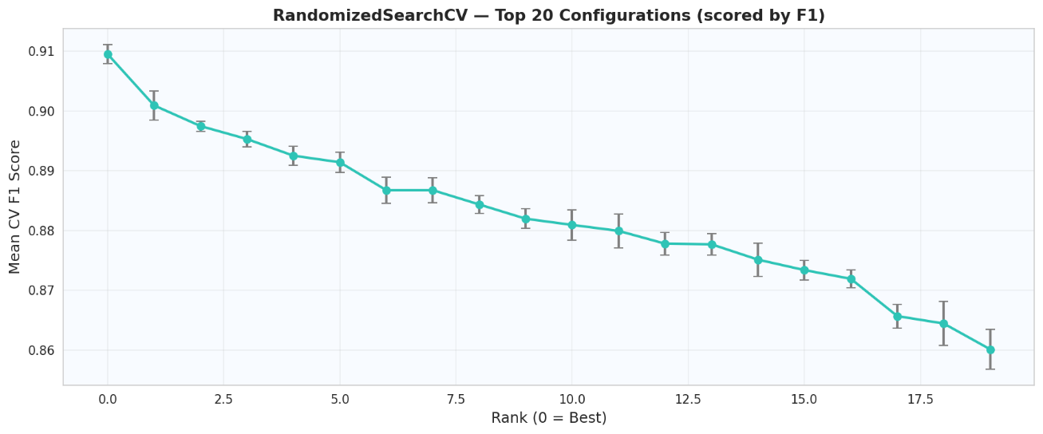

Mean CV Recall Score

Figure 3.8
Top 20 hyperparameter configurations evaluated during RandomizedSearchCV ranked by mean cross-validated Recall with standard deviation error bars.

3.8 Evaluation Metrics

3.8.1 Recall and Precision
Recall measures the fraction of all actual positive cases correctly identified by the classifier, as given in Equation 3.13 [44]. In the context of diabetes screening, Recall directly quantifies the proportion of diabetic individuals correctly flagged for clinical follow-up and is therefore the primary deployment metric.

$\text{ Recall}=\frac{TP}{TP+FN}$(Equation 3.13)

Precision measures the fraction of predicted positive cases that are true positives, as given in Equation 3.14 [44].

$\text{ Precision}=\frac{TP}{TP+FP}$ (Equation 3.14)

3.8.2 F1-Score and Balanced Accuracy
F1-Score is the harmonic mean of Precision and Recall, as given in Equation 3.15 [44]. It provides a balanced single metric for comparing model configurations that differ in their Precision-Recall trade-off.

$F1=2×\frac{\text{Precision}×\text{Recall}}{\text{Precision}+\text{Recall}}$ (Equation 3.15)

Balanced Accuracy is the arithmetic mean of per-class Recall, as given in Equation 3.16 [44], [45]. It correctly rewards classifiers that perform well on both classes independently of the imbalance ratio.

$\text{Balanced Accuracy}=\frac{1}{2}×\frac{TP}{TP+FN}+\frac{1}{2}×\frac{TN}{TN+FP}$(Equation 3.16)

3.8.3 ROC-AUC and PR-AUC
The area under the Receiver Operating Characteristic curve (ROC-AUC) measures the classifier's ability to discriminate between the two classes across all decision thresholds [32]. It has a direct probabilistic interpretation: it equals the probability that a randomly chosen positive instance receives a higher predicted probability than a randomly chosen negative instance, as given in Equation 3.17 [32].

$\text{ AUC}=P\left(F\left(x^{+}\right)>F\left(x^{-}\right)\right)$(Equation 3.17)

An AUC of 0.5 indicates no discriminative ability and 1.0 indicates perfect discrimination. The area under the Precision-Recall curve (PR-AUC) provides a more informative evaluation measure than ROC-AUC in the presence of severe class imbalance because it focuses entirely on minority class performance [31].

3.8.4 Matthews Correlation Coefficient
The Matthews Correlation Coefficient is computed from all four cells of the confusion matrix and produces a correlation coefficient between the observed and predicted binary labels, as given in Equation 3.18 [43].

$\text{ MCC}=\frac{TP×TN-FP×FN}{\sqrt{\left(TP+FP\right)\left(TP+FN\right)\left(TN+FP\right)\left(TN+FN\right)}}$(Equation 3.18)

MCC ranges from -1 to +1, where +1 indicates perfect prediction, 0 indicates random chance, and -1 indicates inverse prediction. A trivial majority-class classifier achieves an overall accuracy of 0.86 on the BRFSS dataset but achieves an MCC of approximately 0, correctly indicating that it has no discriminative value. This makes MCC a more honest and clinically meaningful summary metric than accuracy in this context [43], [45].

3.8.5 Decision Threshold Optimization
The default classification threshold of 0.50 has no clinical justification in an asymmetric screening context and typically produces suboptimal Recall on the diabetic minority class [30]. A systematic threshold optimization procedure is therefore implemented after hyperparameter tuning. The tuned model's probability outputs on the held-out test set are evaluated at 90 candidate thresholds spanning the range from 0.05 to 0.95 in increments of 0.01. At each threshold, Recall, Precision, F1-Score, Accuracy, and MCC are computed and logged.
Four specific thresholds are identified and compared: the default threshold of 0.50, the F1-optimal threshold that maximizes F1-Score, the Youden index threshold computed as the point of maximum separation between the true positive rate and false positive rate on the ROC curve as given in Equation 3.19 [33], and the clinical deployment threshold defined as the highest threshold satisfying Recall greater than or equal to 0.90.

$J=\max_{t}\left(\text{TPR}\left(t\right)-\text{FPR}\left(t\right)\right)$(Equation 3.19)

The clinical deployment threshold is used for all final performance reporting and for the deployment pipeline bundle. Figure 3.9 illustrates the variation of all metrics across the full threshold range with the clinical deployment threshold of 0.53 marked.

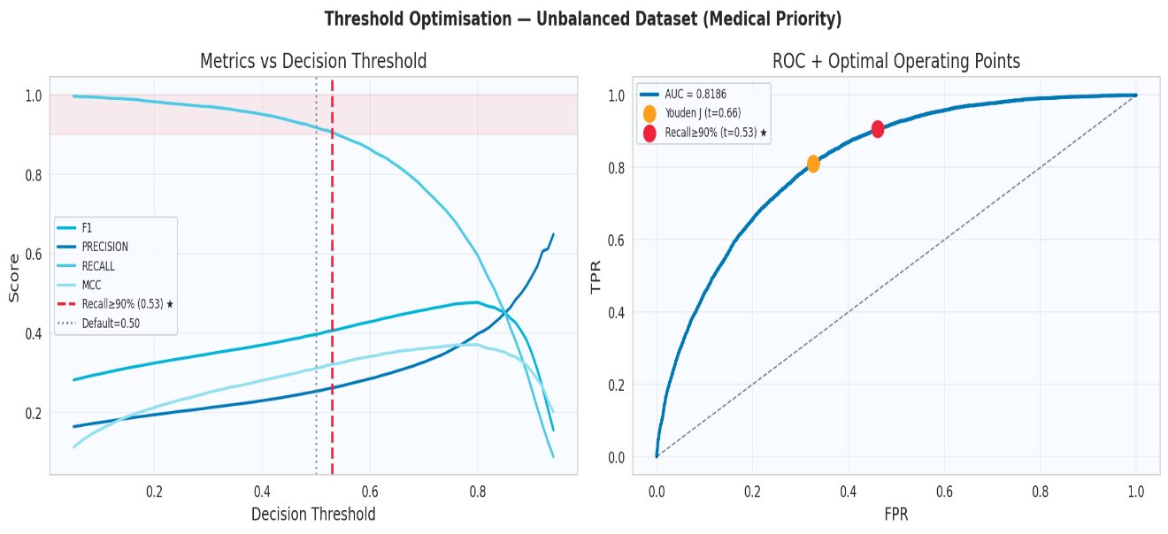

Figure 3.9
Variation of Recall, Precision, F1-Score, and MCC across decision thresholds from 0.05 to 0.95 for the tuned LightGBM model with the clinical deployment threshold of 0.53 marked.

3.9 Final Pipeline Bundle
Following threshold optimization, all components required for deployment are serialized and packaged into a single pipeline bundle dictionary. The bundle contains five elements: the tuned LightGBM model trained on the best-performing feature phase, the RobustScaler fitted exclusively on the corresponding training set, the feature engineering function that transforms raw input into the 45-feature engineered space, the ordered list of features used in the best phase, and the clinical deployment threshold value of 0.53. The complete bundle is serialized as a single pickle file using Python's pickle library, ensuring that every transformation applied during training is preserved exactly and can be reapplied identically at inference time without any recomputation or manual reconstruction [5], [11].
Packaging all components into a single bundle rather than separate files eliminates the risk of version mismatch between the model and its preprocessing steps, which is a common source of silent prediction errors in deployed machine learning systems. Any input passed to the bundle at inference time will undergo the exact same sequence of transformations that the training data underwent, guaranteeing consistent and reproducible predictions [35].
Isotonic recalibration was assessed but ultimately skipped, as gradient boosting models trained on large datasets with explicit cost-sensitive weighting tend to produce sufficiently calibrated probability outputs without post-hoc correction [46].

3.10 System Deployment
The serialized pipeline bundle is integrated into a web-based application built using Streamlit, a Python framework for deploying machine learning models as interactive browser interfaces without requiring any web development expertise [5]. The application is organized as a single-page sequential interface structured into three distinct functional sections visible to the user.
The landing section presents the system identity, a concise clinical description of the pipeline, and a four-metric performance reference panel displaying the model's Clinical Recall of 90.64%, ROC-AUC of 0.8186, PR-AUC of 0.4447, and the total training record count of 253,680. This panel is permanently visible and provides the user with immediate context regarding the clinical reliability of the system before any input is submitted, as illustrated in Figure 3.10.
The patient information section presents the user with a three-column structured input form containing the 21 behavioral and demographic variables required by the model. The form is organized into three labeled panels: Demographics and Physical covering five fields, Health Conditions covering seven fields, and Lifestyle and Healthcare covering nine fields. All binary and ordinal variables are implemented as dropdown selection menus with predefined options, and continuous variables such as BMI and health burden days are implemented as bounded sliders, collectively eliminating the possibility of invalid free-text input. Figure 3.11 shows the complete input form with all three panels.
When the user submits the form by clicking the assessment button, the application passes the raw input values through the feature engineering function to generate the full 45-feature engineered representation, applies the RobustScaler transformation fitted on the training set, and feeds the scaled vector to the tuned LightGBM model to generate a predicted probability. The probability is then compared against the clinical deployment threshold of 0.53. The result section displays the predicted probability as a large numerical value, a horizontal probability bar with a vertical marker at the 53% threshold position, and a four-cell model performance reference panel showing Recall, ROC-AUC, PR-AUC, and MCC. A risk factor panel on the right side identifies the contributing input variables using red indicators for primary clinical risk factors and amber indicators for secondary behavioral factors. A clinical recommendation box and a medical disclaimer are displayed below the risk factors. The application requires no programming knowledge from the end user and is accessible from any device with a web browser [5], [11].
Figure 3.12 shows the result screen for a low-risk classification with probability 2.2%, displaying the identified risk factors and the low-risk clinical recommendation. Figure 3.13 shows the result screen for a high-risk classification with probability 97.2%, displaying all identified risk factors including elevated BMI, high blood pressure, high cholesterol, heart disease history, stroke history, and poor general health, together with the high-risk clinical recommendation directing the user to seek confirmatory laboratory testing.
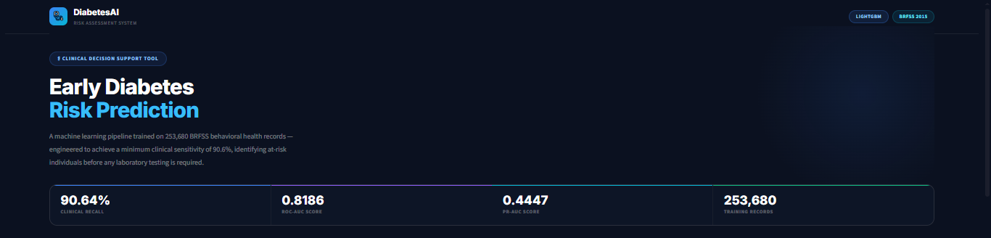

Figure 3.10
Streamlit application landing section showing the system title, clinical description, and model performance panel. Source: Screenshot of the deployed system. Self-captured.

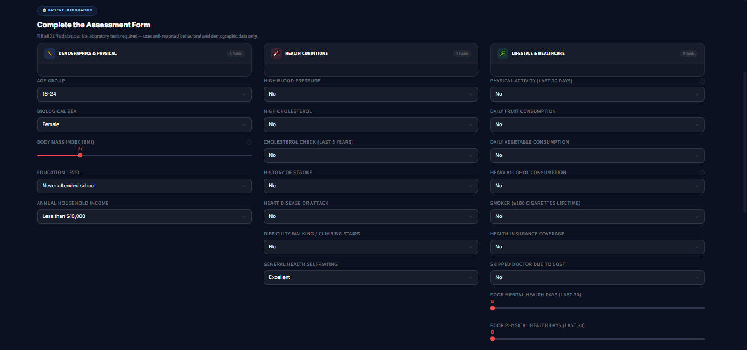

Figure 3.11
Streamlit application patient information form showing the three-column input layout for all 21 BRFSS variables. Source: Screenshot of the deployed system. Self-captured.

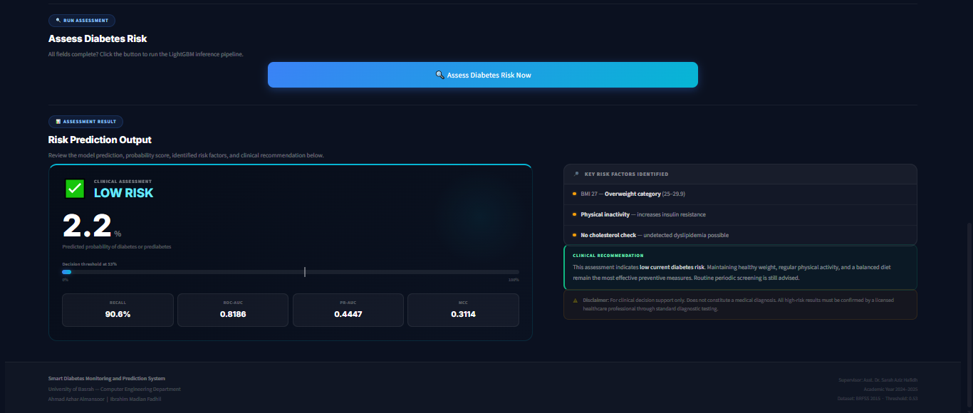

Figure 3.12
Streamlit application result screen for a low-risk classification showing the probability score, threshold bar, and clinical recommendation. Source: Screenshot of the deployed system. Self-captured.

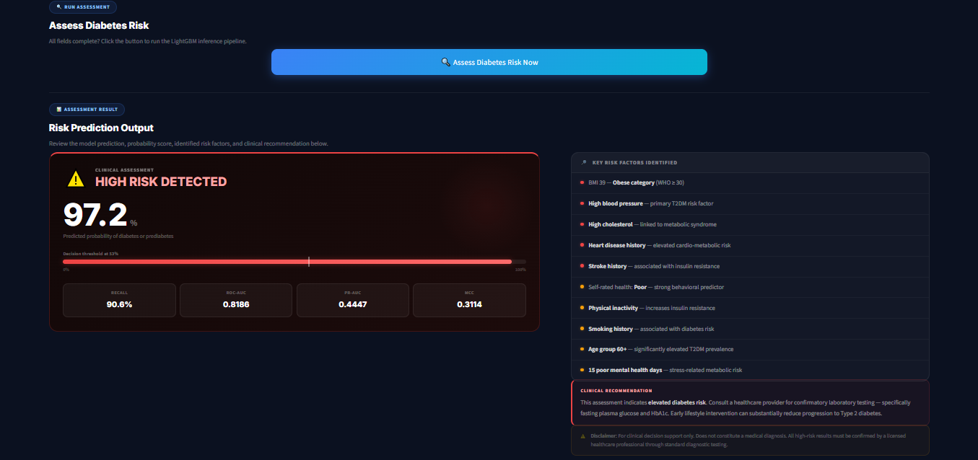

Figure 3.13
Streamlit application result screen for a high-risk classification showing a predicted probability of 97.2% and all identified risk factors. Source: Screenshot of the deployed system. Self-captured.

3.11 Chapter Summary
This chapter documented the complete methodology of the Smart Diabetes Monitoring and Prediction System, covering every design decision from raw data loading to the final deployment bundle. The BRFSS 2015 dataset was preprocessed through duplicate removal, IQR-based outlier capping, stratified 80/20 splitting, and RobustScaler normalization, with a three-layer imbalance handling strategy applied at the data, algorithm, and evaluation levels simultaneously [9], [22], [25]. Domain-informed feature engineering expanded the original 21-feature representation to 45 features through 24 clinically derived attributes, followed by a consensus feature selection procedure combining Random Forest MDI and Mutual Information scores to identify the top 15 most discriminative features for Phase 3 training [17], [37], [38]. Seven classification algorithms were evaluated across three progressive feature phases using a clinically weighted composite scoring function that assigns 40 percent weight to Recall, with the globally best-performing model, LightGBM from Phase 2, subsequently tuned through RandomizedSearchCV over an eleven-parameter search space [15], [42]. A systematic threshold optimization procedure evaluated 90 candidate thresholds and identified 0.53 as the clinical deployment threshold, defined as the highest value satisfying the binding Recall constraint of 0.90, with the tuned model and all preprocessing components packaged into a single serialized pipeline bundle integrated into a Streamlit web application [5], [11], [33].

